Josephine Lo, Tushar Shrivastav

COEN 21L

28 January 2022

Lab 2 Report

Introduction:

We are designing a controller for a system with a switch, motion detector, and disable switch as inputs with light and alarm as the outputs. We will then use Altera Quartus II to design a schematic and the Simulation Waveform Editor to simulate the circuit.

Pre-Lab:

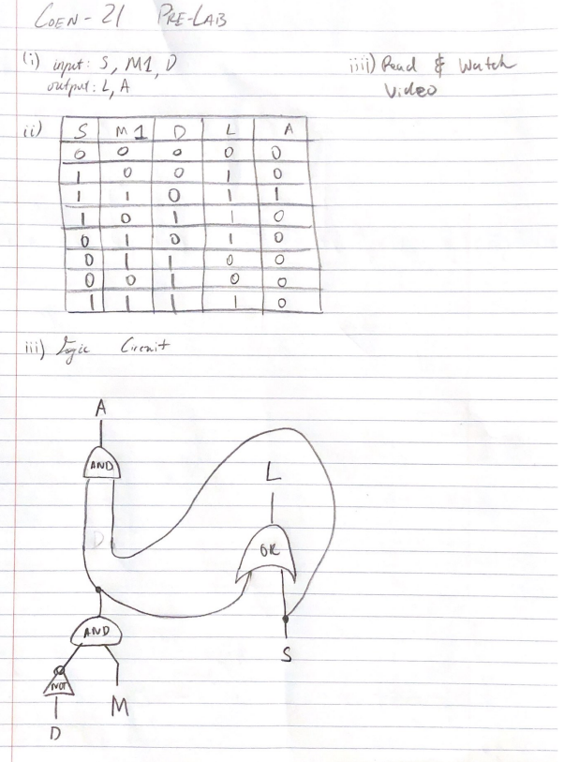

Procedures:

1. Design schematic in Quartus based on Pre-Lab (iii) by following the tutorial
2. Run simulation with the disable feature using the Simulation Waveform Editor by following the tutorial

Schematic:

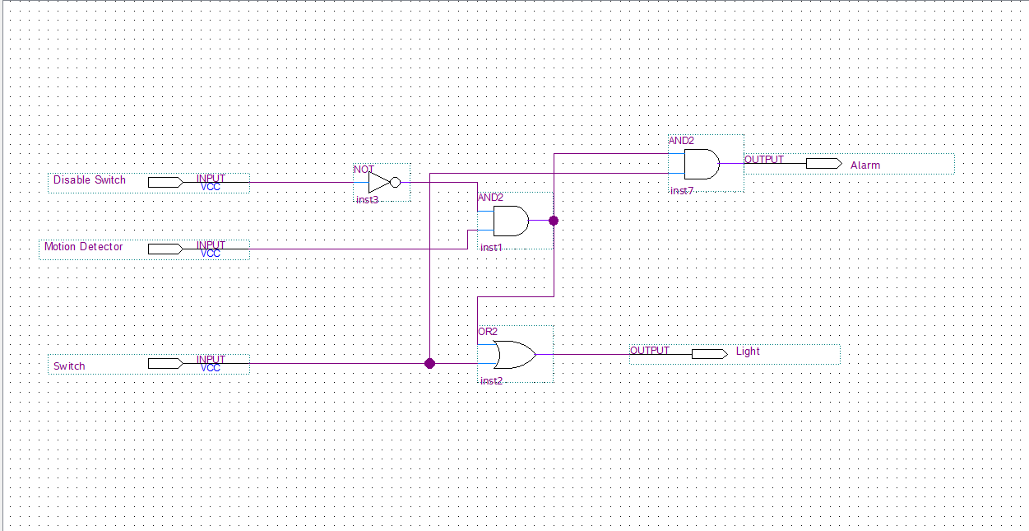

Simulation Results:

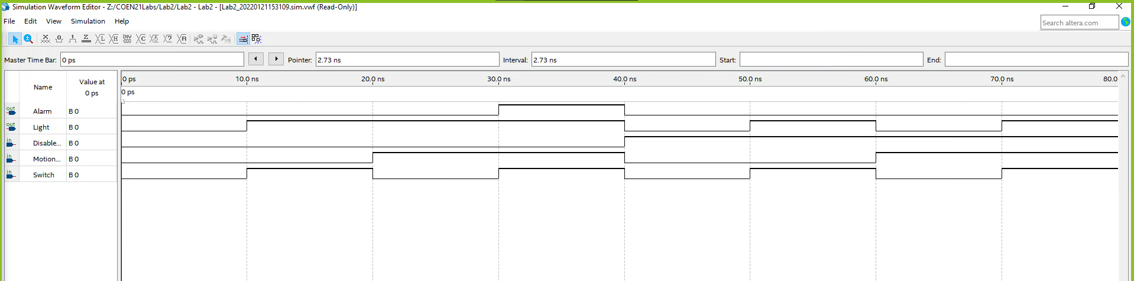

Summary:

We could have made the truth table more easily read to work for the simulation.

Explanation of the simulation:

Highbars represent 1 input and low bars represent 0 input (similarly for output). So we tested all possible inputs from our truth table, and our alarm and light results were consistent with the truth table.